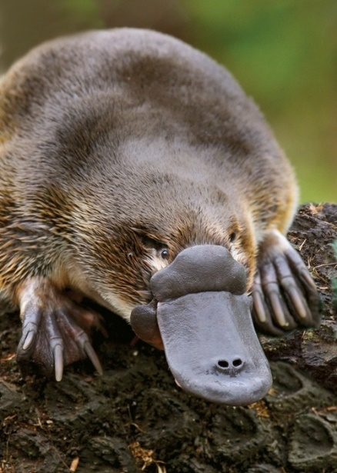
10/5/2020 – SERVICE PROJECT: In God’s Creation
Your job as a small group is to prepare pictures and factoids about creation that you can share with the other small groups during the October 19 class time. Even those of you working strictly online can get involved.
Here’s the idea:
- If you have a smartphone or camera, take pictures or video of one or more of the following. (You can probably do the same thing by simply searching online):

  - Your favorite parts of creation (e.g., specific animals, locations, etc.).

  - Places or issues in creation that cause you great concern (e.g., the effect of pollution, shrinking natural resources, etc.) and need our attention.

- Have any factoids about God’s creation (whether amazing, depressing, or inspiring)? Type it up!

- Share your findings in digital form with Pastor Steve no later than Wednesday, October 14, so that he can get things organized to share at the October 19 class time. Submissions may be made as a finished product (e.g., PowerPoint, complete with music) or separate elements via…

  - Text message to (906) 458-2145
  - Email to PastorSteve@ImmanuelNegaunee.org
  - Upload to https://1drv.ms/u/s!AjOGpGTcDMBVg-ZJyjsfGqp5WXVoAA?e=kmyIxa

- Beyond October 19, I hope to share our perspectives of God’s creation and call to care with the whole congregation at weekly worship, online, and more.

