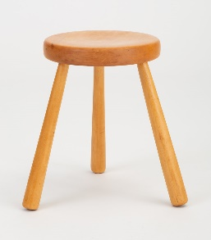
9/28/2020 – Creating a Small Group Covenant
Are you a visual person? Imagine a 3-legged stool with three different legs: 1) Connecting with God; 2) Caring for one another; and 3) Serving others in Jesus’ name. Our confirmation experience “sits” on such a foundation. As you consider the year ahead, what commitment can you make to each other to help each other continue (or start?) to “sit” on such a “stool”?
- Connecting with God:
- Show up for confirmation
- Place worship as a priority within our week (9:30am Sundays, 6:00pm Mondays, church website), feasting on God’s Word and Sacraments
- Practice family home huddles at least once/week (resources on church website)
- Read my Bible at home (starting out with Genesis 1-3 and readings as assigned)
- Make prayer time with God, even if for just a minute, a normal part of my day
- Be honest with myself and God about my certainties and questions of faith
- Other(s)

- Caring for one another:
- Show up for confirmation and pay attention to what’s going on
- If I cannot make the gathering due to sickness, etc., let my small group guide and Pastor Steve know
- Show respect for my small group guide and other adults who give of themselves for my care
- With others in my group, co-create a place of trust and safety where confidences are kept confident
- Respect others both in my small group and the large group, including truly listening to their questions and ideas, even if I disagree with them
- Be honest with myself about my own questions and ideas and, as appropriate, risk sharing out loud
- Pray for others in the group throughout the week
- Other(s)

- Serving others in Jesus’ name:
- Consider myself a member of the greater Immanuel community, that could use my time & abilities
- Ask the question: How can I use my life this day to serve others in the church and beyond?
- Listen for the Holy Spirit’s sharing opportunities to care for those around me and God’s world in which I live
- As I listen, invite the Spirit’s guidance in when to act and when to stay still
- Invite God to use the service I share to make God’s world better, even if I may not see the results
- Other(s)

Date:
Signatures of Small Group Guide & Members:

